18.56: a) The height 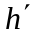 at this depth will be proportional to the volume, and hence inversely proportional to the pressure and proportional to the Kelvin temperature;

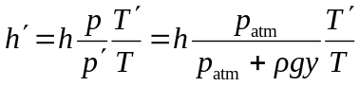

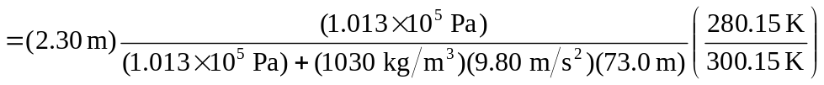

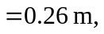

so 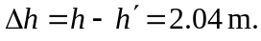 b) The necessary gauge pressure is the term  from the above calculation, 